Project 3

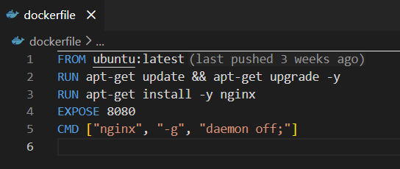
- Tells docker to pull the latest official Ubuntu image from docker hub
- Updates the list of available packages and upgrades any existing software to latest verions. -y flag is used to automatically answer the ‘yes or no’ prompt.
- This installs the nginx web server into your container
- Tells docker that application intends to use port 8080
- This is the command that executes when the container starts. Tells nginx to stay in the foreground making sure the container remains active and running.

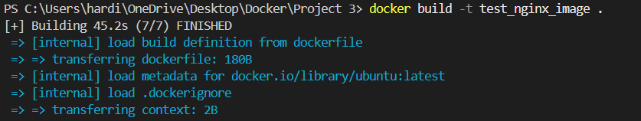
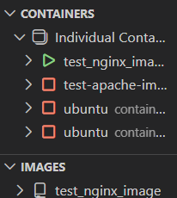
- We open a new terminal
- The docker build commands builds the image.
- Docker run command creates a new container which runs the image the we created.

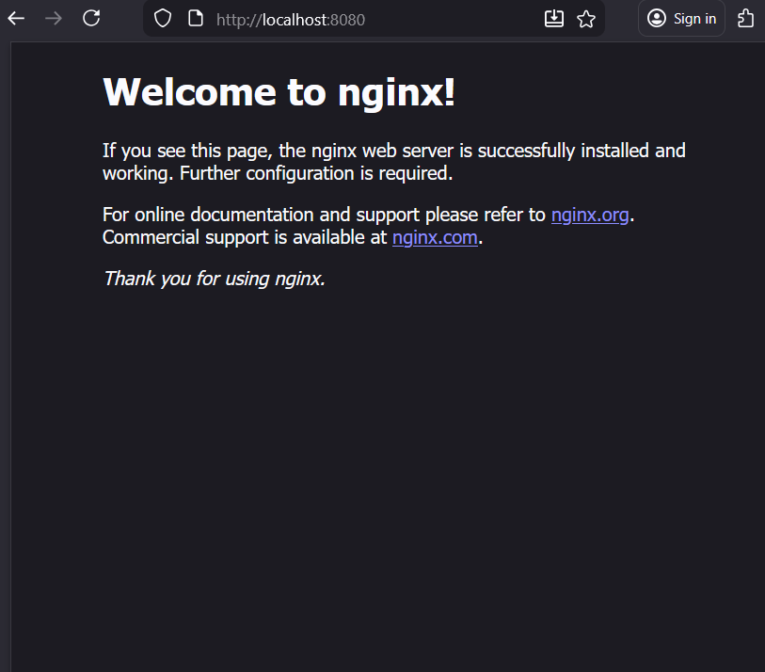
- Test whether nginx web server is successfully installed.

- We create a new folder in our project3 folder
- We create a new html file in the app folder

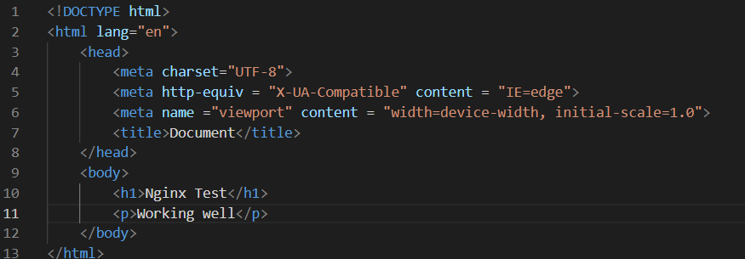
- A simple html layout

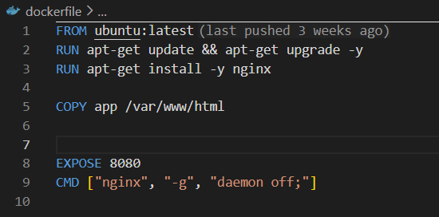
- We add a new line in our dockerfile.
- Docker creates the mentioned destination, takes the contents of the app folder, and places them into the containers directory. Thus creating a read only layer in your Docker image containing those files.

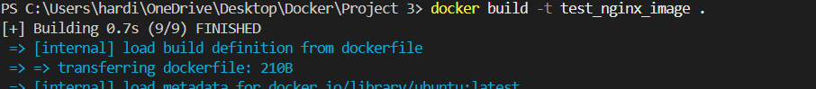
- We create our image again and run the container as we’ve made changes to the docker file.

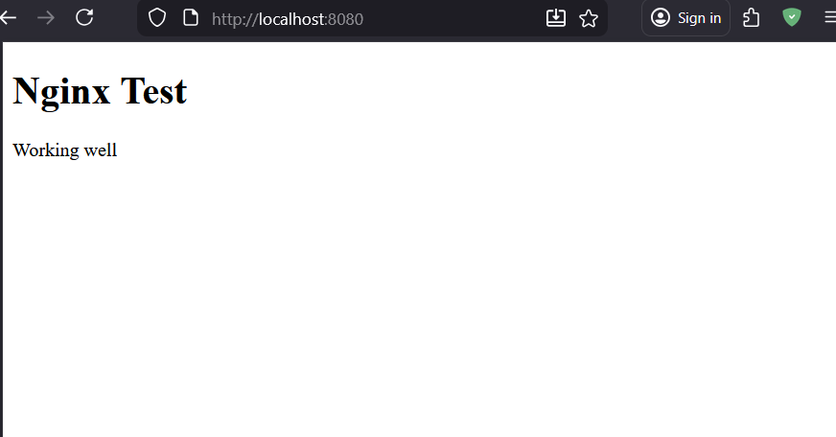
1, We enter localhost:8080 and voila.

